CIS 344 FINAL PROJECT

“Hospital Portal”

Brandon Chong

Prof. Yanilda Peralta Ramos

The structure includes three main tables: patients, doctors, and appointments. Additionally, stored procedures for scheduling appointments and discharging patients are defined, and a view named doctors_appointments_patients is created for simplified data retrieval.

The patient ID serves as the primary key, ensuring a unique identifier for each patient in the table. It is used to uniquely identify and distinguish one patient from another. The patient name stores the name of the patient. It is a VARCHAR type, allowing for the storage of variable-length character strings. The patient name is a critical piece of information for identification and reference. The age records the age of each patient. It stores an integer value representing the patient's age at the time of admission. The admission date captures the date when a patient is admitted to the hospital. It is of the DATE type, allowing the storage of dates without a time component. The discharge date records the date when a patient is discharged from the hospital.

The doctor ID serves as the primary key and is auto-incremented. It provides a unique identifier for each doctor in the table. The doctor name stores the name of the doctor, providing a human-readable identifier for each medical professional. Specialization captures the specialization or field of expertise for each doctor. It helps in categorizing and organizing doctors based on their medical focus, i.e. Cardiology, neurology, etc. This is also done with the appointment table with the appropriate attributes.

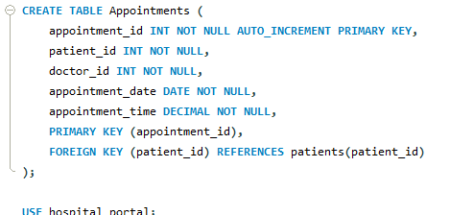

The stored procedure scheduleAppointment is designed to insert a new appointment into the appointments table. It takes four parameters: p_patient_id, p_doctor_id, p_appointment_date, p_appointment_time. The stored procedure encapsulates the logic for creating a new appointment, abstracting the details of the underlying SQL insert operation. It allows for easy and consistent scheduling of appointments by providing a centralized procedure to handle this common task. The usage of parameters makes the stored procedure versatile, enabling the scheduling of appointments with different patients, doctors, dates, and times.

The CALL statement in SQL is used to invoke or execute a stored procedure or a function.

